CT331 Assignment 1

# **Jobe George – 16323856**

<https://github.com/JobeGeo26/CT331_Assignment1>

# **Question 1**

**(A)**

**Assignment.c**

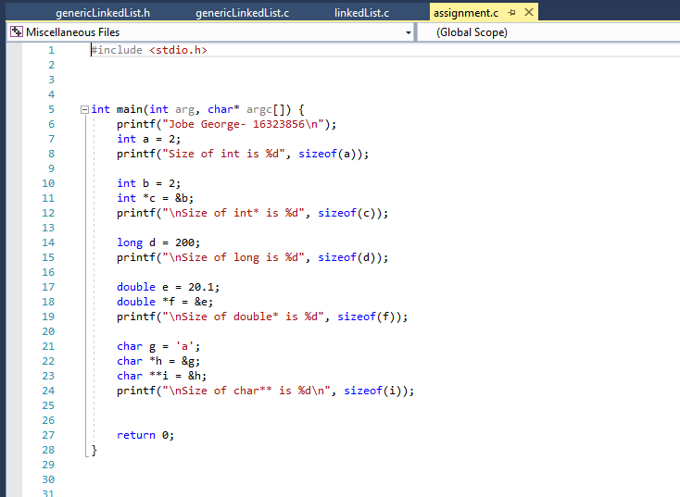

#include <stdio.h>

int main(int arg, char* argc[]) {

printf("Jobe George- 16323856\n");

int a = 2;

printf("Size of int is %d", sizeof(a));

int b = 2;

int *c = &b;

printf("\nSize of int* is %d", sizeof(c));

long d = 200;

printf("\nSize of long is %d", sizeof(d));

double e = 20.1;

double *f = &e;

printf("\nSize of double* is %d", sizeof(f));

char g = 'a';

char *h = &g;

char **i = &h;

printf("\nSize of char** is %d\n", sizeof(i));

return 0;

}

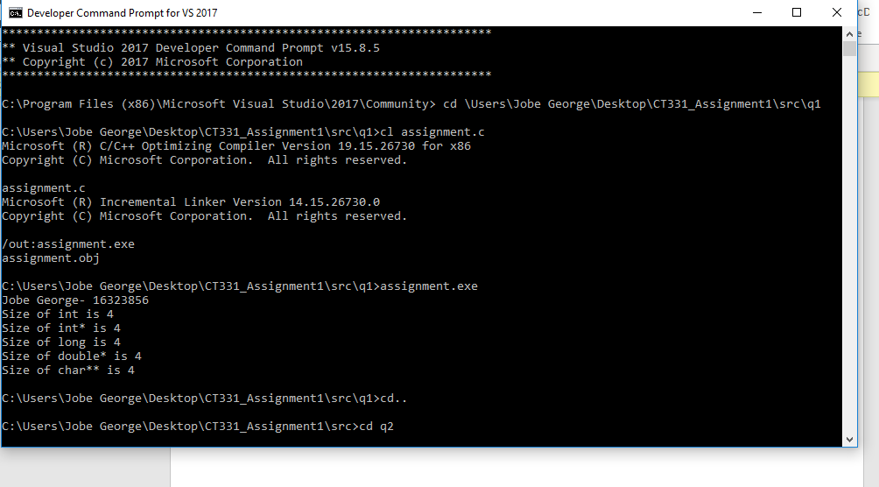

1(B) The size of each pointer type turns out to be 4. Through knowledge we know that pointers typically have a size of 4 bytes. Also, data types int and long also have 4 bytes size in C.

# **Question 2**

**LinkedList.h**

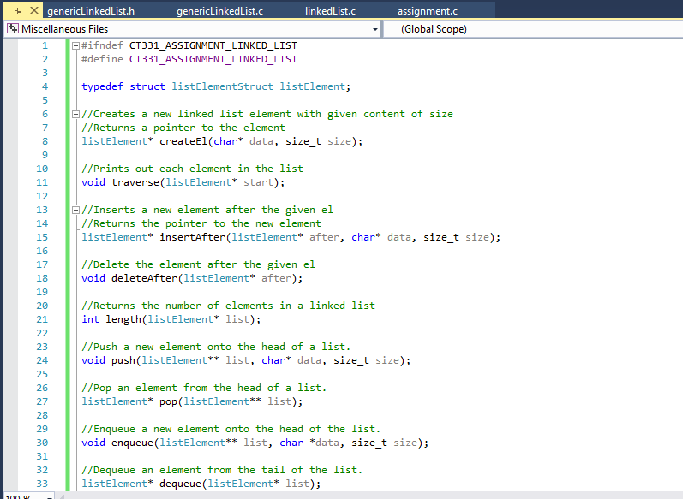

#ifndef CT331_ASSIGNMENT_LINKED_LIST

#define CT331_ASSIGNMENT_LINKED_LIST

typedef struct listElementStruct listElement;

//Creates a new linked list element with given content of size

//Returns a pointer to the element

listElement* createEl(char* data, size_t size);

//Prints out each element in the list

void traverse(listElement* start);

//Inserts a new element after the given el

//Returns the pointer to the new element

listElement* insertAfter(listElement* after, char* data, size_t size);

//Delete the element after the given el

void deleteAfter(listElement* after);

//Returns the number of elements in a linked list

int length(listElement* list);

//Push a new element onto the head of a list.

void push(listElement** list, char* data, size_t size);

//Pop an element from the head of a list.

listElement* pop(listElement** list);

//Enqueue a new element onto the head of the list.

void enqueue(listElement** list, char *data, size_t size);

//Dequeue an element from the tail of the list.

listElement* dequeue(listElement* list);

#endif

**LinkedList.c**

#include <stdio.h>

#include <stdlib.h>

#include <string.h>

#include "linkedList.h"

typedef struct listElementStruct{

char* data;

size_t size;

struct listElementStruct* next;

} listElement;

//Creates a new linked list element with given content of size

//Returns a pointer to the element

listElement* createEl(char* data, size_t size){

listElement* e = malloc(sizeof(listElement));

if(e == NULL){

//malloc has had an error

return NULL; //return NULL to indicate an error.

}

char* dataPointer = malloc(sizeof(char)*size);

if(dataPointer == NULL){

//malloc has had an error

free(e); //release the previously allocated memory

return NULL; //return NULL to indicate an error.

}

strcpy(dataPointer, data);

e->data = dataPointer;

e->size = size;

e->next = NULL;

return e;

}

//Prints out each element in the list

void traverse(listElement* start){

listElement* current = start;

while(current != NULL){

printf("%s\n", current->data);

current = current->next;

}

}

//Inserts a new element after the given el

//Returns the pointer to the new element

listElement* insertAfter(listElement* el, char* data, size_t size){

listElement* newEl = createEl(data, size);

listElement* next = el->next;

newEl->next = next;

el->next = newEl;

return newEl;

}

//Delete the element after the given el

void deleteAfter(listElement* after){

listElement* delete = after->next;

listElement* newNext = delete->next;

after->next = newNext;

//need to free the memory because we used malloc

free(delete->data);

free(delete);

}

// Returns the number of elements in a linked list.

int length(listElement* list) {

int counter = 0;

listElement* temp = list;

while (temp != NULL) {

temp = temp->next;

counter++;

}

return counter;

}

// Push a new element onto the head of a list.

void push(listElement** list, char *data, size_t size) {

listElement* node = createEl(data, size);

node->next = *list;

*list = node;

}

// Pop an element from the head of a list.

listElement* pop(listElement** list) {

if (*list != NULL) {

listElement* node = (*list)->next;

*list = (*list)->next;

return node;

}

return *list;

}

//Enqueue a new element onto the head of the list.

void enqueue(listElement** list, char* data, size_t size) {

push(list, data, size);

}

//Dequeue an element from the tail of the list.

listElement* dequeue(listElement* list) {

listElement* temp = list;

while ((temp->next)->next != NULL)

{

temp = temp->next;

}

listElement* last = temp->next;

temp->next = NULL;

return last;

}

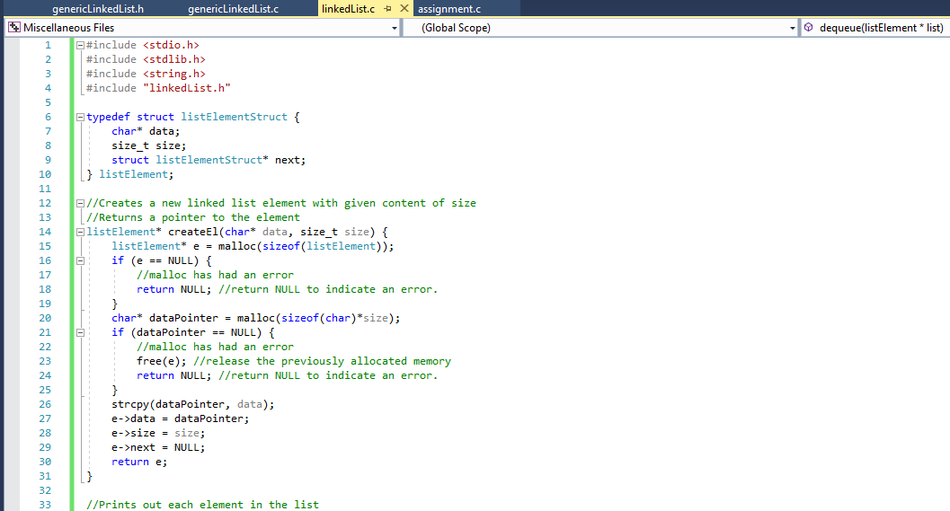

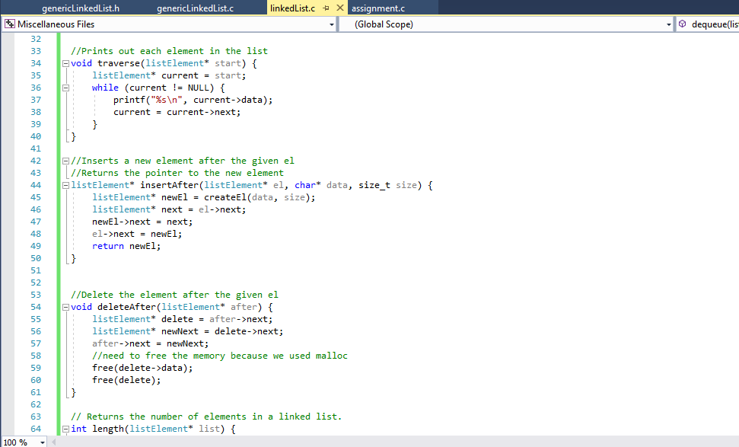

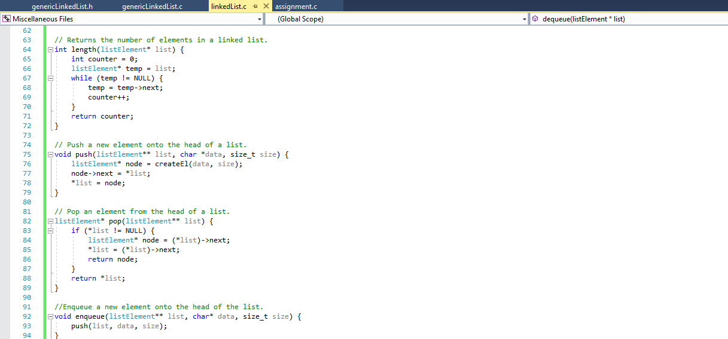

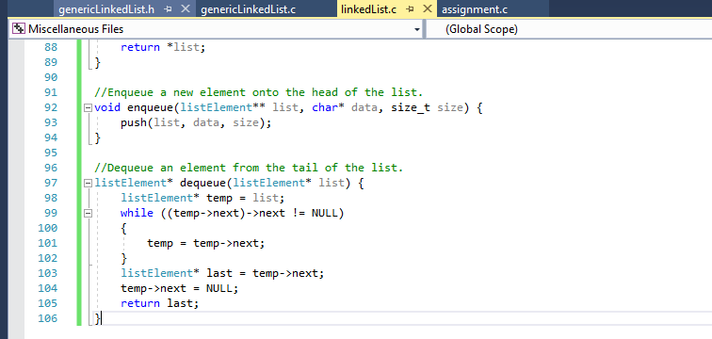

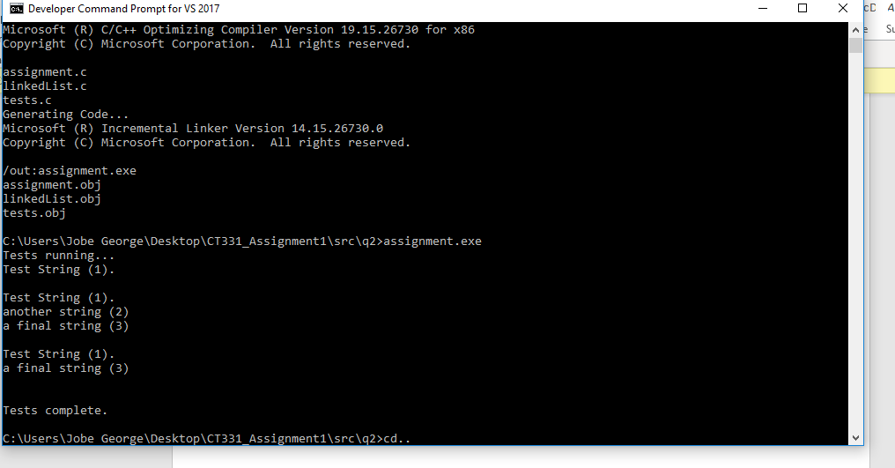

# **Question 3**

**genericLinkedList.h**

#ifndef CT331_ASSIGNMENT_GENERIC_LINKED_LIST

#define CT331_ASSIGNMENT_GENERIC_LINKED_LIST

typedef void(*printFn)(void* data);

typedef struct genericlistElementStruct {

void* data;

size_t size;

printFn print;

struct genericlistElementStruct* next;

} genericlistElement;

//Creates a new linked list element with given content of size

//Returns a pointer to the element

genericlistElement* createEl(void* data, size_t size, printFn print);

//Prints out each element in the list

void traverse(genericlistElement* start);

//Inserts a new element after the given el

//Returns the pointer to the new element

genericlistElement* insertAfter(genericlistElement* after, void* data, size_t size, printFn print);

//Delete the element after the given el

void deleteAfter(genericlistElement* after);

//Returns the number of elements in a linked list

int length(genericlistElement* list);

//Push a new element onto the head of a list.

void push(genericlistElement** list, void* data, size_t size, printFn print);

//Pop an element from the head of a list.

genericlistElement* pop(genericlistElement** head);

//Enqueue a new element onto the head of the list.

void enqueue(genericlistElement** list, void* data, size_t size, printFn print);

//Dequeue an element from the tail of the list.

genericlistElement* dequeue(genericlistElement* list);

//Prints out an integer element

void printInt(void* data);

//Prints out a float element

void printFloat(void* data);

//Prints out a char element

void printChar(void* data);

//Prints out a string element

void printStr(void* data);

#endif

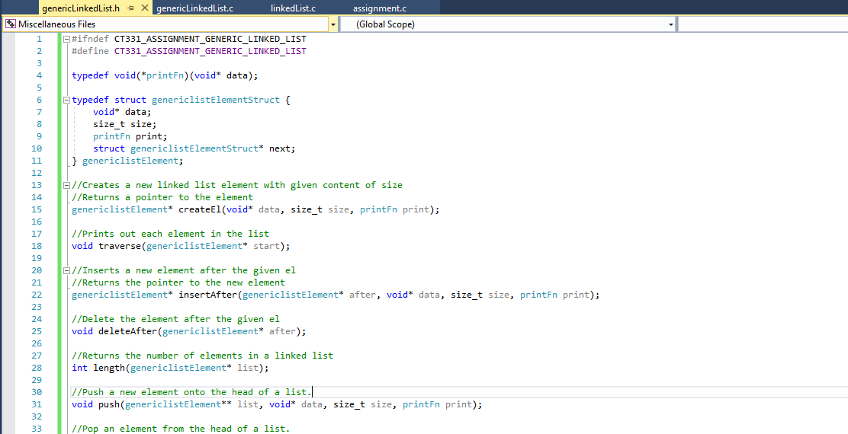

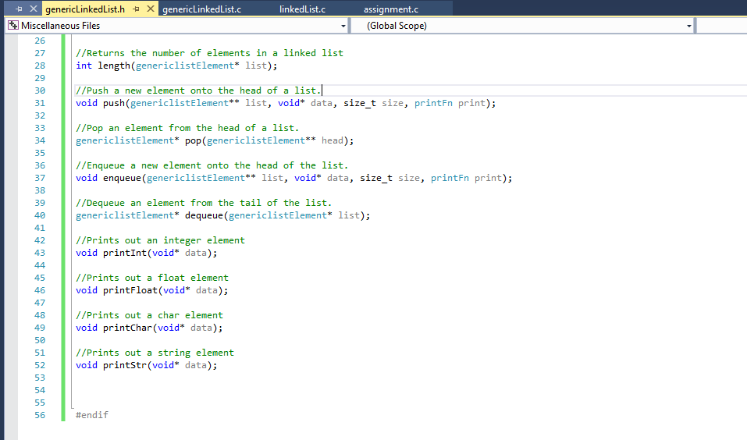

**genericLinkedList.c**

#include <stdio.h>

#include <stdlib.h>

#include <string.h>

#include "genericLinkedList.h"

//Creates a new linked list element with given content of size

//Returns a pointer to the element

genericlistElement* createEl(void* data, size_t size, printFn print) {

genericlistElement* e = malloc(sizeof(genericlistElement));

if (e == NULL) {

//malloc has had an error

return NULL; //return NULL to indicate an error.

}

void* dataPointer = malloc(size);

if (dataPointer == NULL) {

//malloc has had an error

free(e); //release the previously allocated memory

return NULL; //return NULL to indicate an error.

}

memmove(dataPointer, data, size);

e->data = dataPointer;

e->size = size;

e->print = print;

e->next = NULL;

return e;

}

//Prints out each element in the list

void traverse(genericlistElement* head) {

genericlistElement* current = head;

while (current != NULL) {

current->print(current->data);

current = current->next;

}

}

//Inserts a new element after the given el

//Returns the pointer to the new element

genericlistElement* insertAfter(genericlistElement* el, void* data,

size_t size, printFn print) {

genericlistElement* newEl = createEl(data, size, print);

genericlistElement* next = el->next;

newEl->next = next;

el->next = newEl;

return newEl;

}

//Delete the element after the given el

void deleteAfter(genericlistElement* after) {

genericlistElement* delete = after->next;

genericlistElement* newNext = delete->next;

after->next = newNext;

//need to free the memory because we used malloc

free(delete->data);

free(delete);

}

// Returns the number of elements in a linked list.

int length(genericlistElement* list) {

int c = 0;

genericlistElement* temp = list;

while (temp != NULL) {

temp = temp->next;

c++;

}

return c;

}

// Push a new element onto the head of a list.

void push(genericlistElement** list, void* data, size_t size, printFn print) {

genericlistElement* node = createEl(data, size, print);

node->next = *list;

*list = node;

}

// Pop an element from the head of a list.

genericlistElement* pop(genericlistElement** list) {

if (*list != NULL) {

genericlistElement* n = (*list)->next;

*list = (*list)->next;

return n;

}

return *list;

}

//Enqueue a new element onto the head of the list.

void enqueue(genericlistElement** list, void* data, size_t size, printFn print) {

push(list, data, size, print);

}

//Dequeue an element from the tail of the list.

genericlistElement* dequeue(genericlistElement* list) {

genericlistElement* temp = list;

while (temp->next->next != NULL) {

temp = temp->next;

}

genericlistElement* t = temp->next;

temp->next = NULL;

return t;

}

void printChar(void* data){

printf("%c\n", *(char*)data);

}

//Print an integer element

void printInt(void* data){

printf("%d\n", *(int*)data);

}

//Print a float element

void printFloat(void* data){

printf("%f\n", *(float*)data);

}

//Print a string element

void printStr(void* data){

printf("%s\n", data);

}

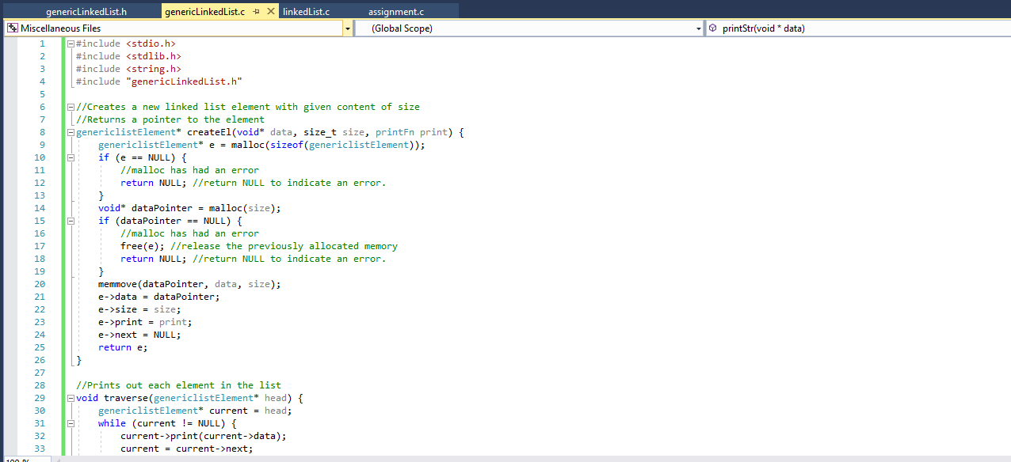

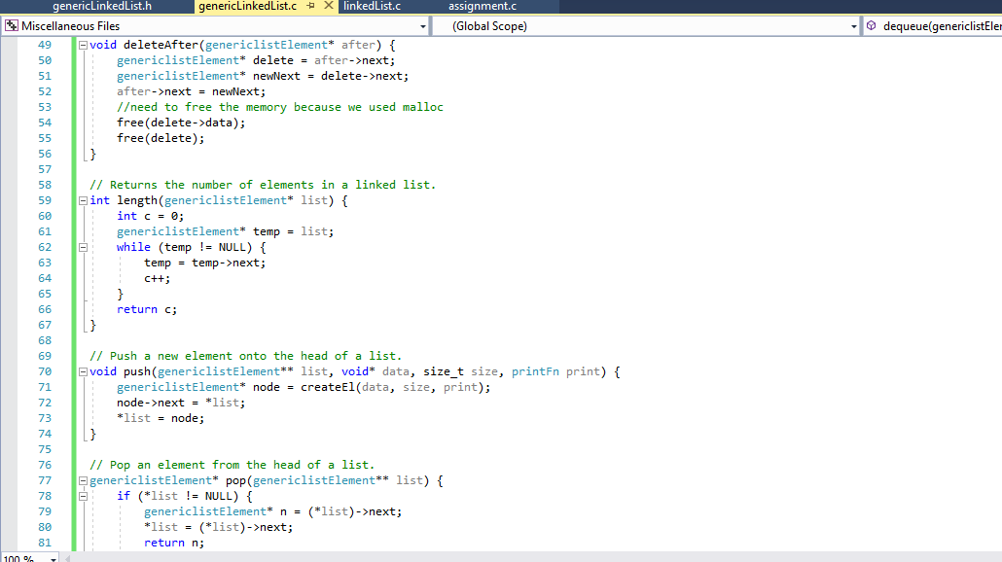

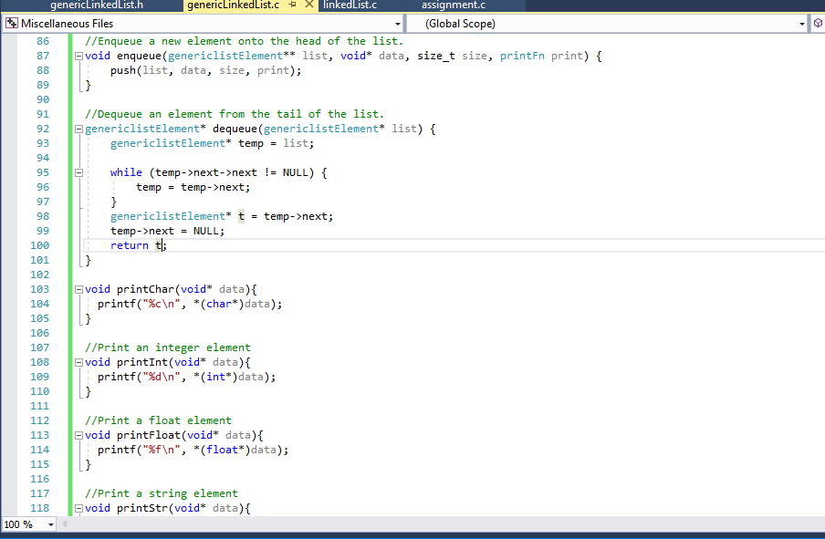

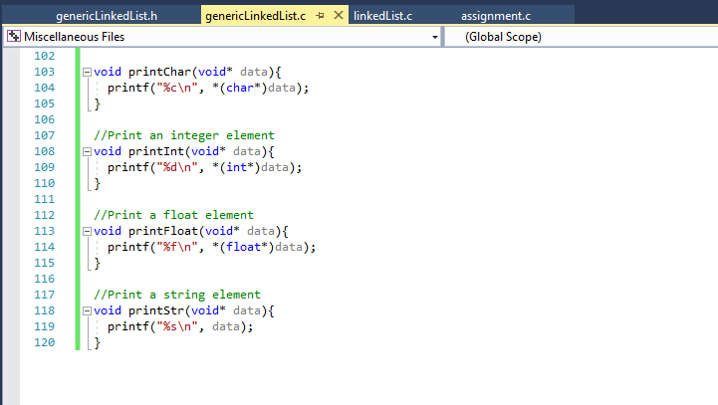

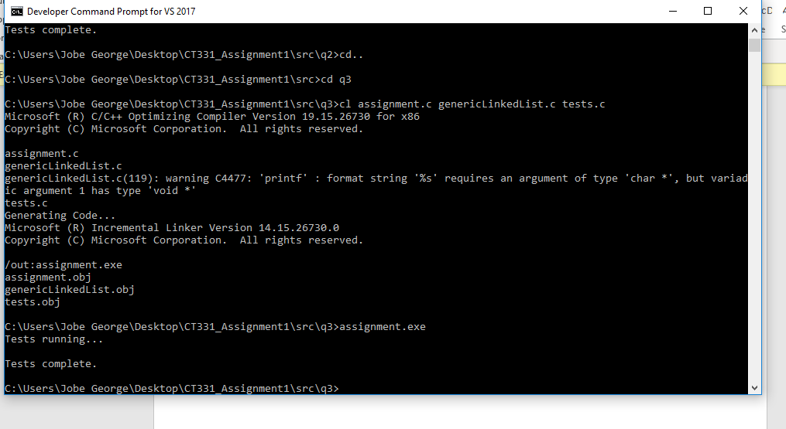

# **Question 4**

1. A Singly Linked List would result in huge memory intensity to traverse in reverse because it has no pointer to previous node so would require you to iterate through the list once again which results in a lot of memory.
2. A solution should be to change its structure to a Doubly Linked List which has a reference to the previous nodes which makes traversing in reverse much easier and much more efficient. Doubly Linked List require more storage than Singly Linked List but it’s much more efficient and requires lot less memory for traversing in reverse in huge lists using Singly Linked List